Assignment 5
Name: Parth Koshti
PRN: 24070126093
Batch: AIML B1

Title: Banking Application: Design an inheritance-based banking system with account types and overridden methods.

Code 1) Account.java
public class Account {
protected int accountNumber;
protected double balance;
protected customer customer;
private ArrayList<String> transactionHistory = new ArrayList<>();

public Account(int accountNumber, double balance, customer customer) {
this.accountNumber = accountNumber;
this.balance = balance;
this.customer = customer;
}

public void deposit(double amount) {
balance += amount;
transactionHistory.add("Deposited: " + amount + ", Balance: " + balance);
System.out.println("Amount Deposited: " + amount);
System.out.println("Balance: " + balance);
}

public void withdraw(double amount) throws InsufficientBalanceException {
if (amount > balance)
throw new InsufficientBalanceException("Insufficient Balance");
balance -= amount;
transactionHistory.add("Withdrawn: " + amount + ", Balance: " + balance);
System.out.println("Amount Withdrawn: " + amount);
System.out.println("Balance: " + balance);
}

public void displayAccount() {
customer.displayCustomer();
System.out.println("Account Number: " + accountNumber);
System.out.println("Balance: " + balance);
}

public void printTransactionHistory() {
System.out.println("--- Transaction History ---");
for (String t : transactionHistory) {
System.out.println(t);
}
}
}

Code 2) Customer.java
public class customer {
public String customerID;
public String firstName;
public String lastName;
public String email;
public String phoneNumber;
public String address;
protected String aadharID;
protected String panID;
public customer(String customerID, String firstName, String lastName, String email, String phoneNumber, String address, String aadharID, String panID) {
this.customerID = customerID;
this.firstName = firstName;
this.lastName = lastName;
this.email = email;
this.phoneNumber = phoneNumber;
this.address = address;
this.aadharID = aadharID;
this.panID = panID;
}
public void displayCustomer() {
System.out.println("Customer ID: " + customerID);
System.out.println("Name: " + firstName + " " + lastName);
System.out.println("Email: " + email);
System.out.println("Phone: " + phoneNumber);
System.out.println("Address: " + address);
System.out.println("Aadhar ID: " + aadharID);
System.out.println("PAN ID: " + panID);
}
}
Code 3) CurrentAccount.java
public class CurrentAccount extends Account {
double minimumBalance = 500;
public CurrentAccount(int accountNumber, double balance, customer customer) {
super(accountNumber, balance, customer);
}
public void checkMinimumBalance() {
if(balance < minimumBalance)
System.out.println("Minimum balance not maintained");
else
System.out.println("Minimum balance maintained");
}
public void withdraw(double amount) throws InsufficientBalanceException {
if(amount > balance)
throw new InsufficientBalanceException("Insufficient Balance");
balance -= amount;
System.out.println("Current Account Withdrawal: " + amount);
}
}
Code 4) SavingAccount.java
public class SavingsAccount extends Account {
double interestRate = 0.067;
public SavingsAccount(int accountNumber, double balance, customer customer) {
super(accountNumber, balance, customer);
}
public void calculateInterest() {
double interest = balance * interestRate;
System.out.println("Interest Earned: " + interest);
}
public void withdraw(double amount) throws InsufficientBalanceException {
if(balance - amount < 500)
throw new InsufficientBalanceException("Minimum balance 500 required");
balance -= amount;
System.out.println("Savings Withdrawal: " + amount);
}
}
Code 5) Loan.java
public class Loan {
double loanAmount;
int months;
double emi;
public Loan(double loanAmount, int months) {
this.loanAmount = loanAmount;
this.months = months;
this.emi = loanAmount / months;
}
public void payEMI(Account acc) throws InsufficientBalanceException {
if(acc.balance < emi)
throw new InsufficientBalanceException("Not enough balance to pay EMI");
acc.balance -= emi;
System.out.println("EMI Paid: " + emi);
System.out.println("Remaining Balance: " + acc.balance);
}
public void displayLoan() {
System.out.println("Loan Amount: " + loanAmount);
System.out.println("Monthly EMI: " + emi);
}
}
Code 6) Main.java
import java.util.ArrayList;
public class Main {
public static void main(String[] args) {
try {
ArrayList<customer> customers = new ArrayList<>();
customer c1 = new customer("1`", "Parth", "Koshti", "kavishnag13@gmail.com", "9829334567", "Pune", "12345678910", "ABCDEFGHIJK");
customer c2 = new customer("2", "Kavish", "Nag", "kavish.nag@gmail.com", "9876534567", "Pune", "98765432109", "XYZABCDEFGH");
customer c3 = new customer("3", "krrish", "koshti", "krrish.koshti@gmail.com", "9123345678", "Pune", "12341234123", "PQRSTUVWXYZ");
customers.add(c1);
customers.add(c2);
customers.add(c3);
ArrayList<Account> accounts = new ArrayList<>();
SavingsAccount sa1 = new SavingsAccount(1001, 50000, c1);
CurrentAccount ca1 = new CurrentAccount(2001, 30000, c1);
accounts.add(sa1);
accounts.add(ca1);
SavingsAccount sa2 = new SavingsAccount(1002, 5000, c2);
CurrentAccount ca2 = new CurrentAccount(2002, 150000, c2);
accounts.add(sa2);
accounts.add(ca2);
SavingsAccount sa3 = new SavingsAccount(1003, 8000, c3);
accounts.add(sa3);
System.out.println("\n Performing Transactions \n");
sa1.deposit(2000);
sa1.withdraw(1000);
sa1.calculateInterest();
sa1.printTransactionHistory();
System.out.println();
Loan loan = new Loan(12000, 12);
loan.displayLoan();
loan.payEMI(sa1);
System.out.println("\n Customer and Account summary:\n");
displayInfo(customers, accounts);
} catch(InsufficientBalanceException e) {
System.out.println("Exception: " + e.getMessage());
}
}
public static void displayInfo(ArrayList<customer> customers, ArrayList<Account> accounts) {
for(customer cust : customers) {
System.out.println("---- CUSTOMER DETAILS ----");
cust.displayCustomer();
System.out.println("\n---- ACCOUNTS ----");
double totalBalance = 0;
int accountCount = 0;
for(Account acc : accounts) {
if(acc.customer.customerID.equals(cust.customerID)) {
System.out.println("Account Number: " + acc.accountNumber);
System.out.println("Account Type: " + acc.getClass().getSimpleName());
System.out.println("Balance: Rs. " + acc.balance);
acc.printTransactionHistory();
totalBalance += acc.balance;
accountCount++;
System.out.println();
}
}
}
}
}

Code 7) InsufficientBalanceException.java
public class InsufficientBalanceException extends Exception {
public InsufficientBalanceException(String msg) {
super(msg);}}
Code 8) InsufficientAccountException.java

public class InvalidAccountException extends Exception {
public InvalidAccountException(String msg) {
super(msg);
}
}

Output:

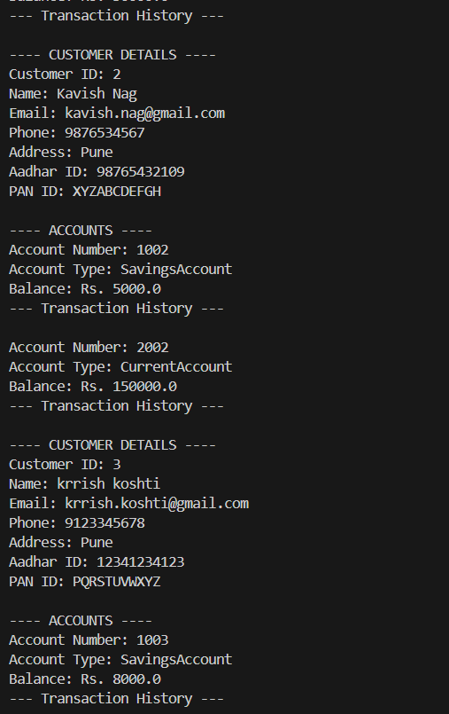
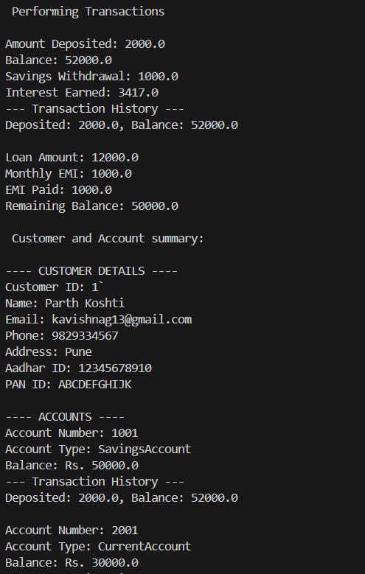

Exceptions:
- Insufficient Balance Exception
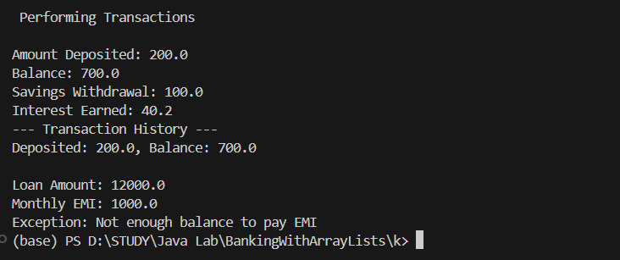

- Invalid Account Exception
